PART 3 – MongoDB

0. Install mongoDB

https://www.8host.com/blog/ustanovka-mongodb-v-centos-7/

nano /etc/yum.repos.d/mongodb-org.repo

add to file:

[mongodb-org-3.2]

name=MongoDB Repository  
baseurl=https://repo.mongodb.org/yum/redhat/$releasever/mongodb-org/3.2/x86_64/  
gpgcheck=1  
enabled=1  
gpgkey=https://www.mongodb.org/static/pgp/server-3.2.asc

yum repolist

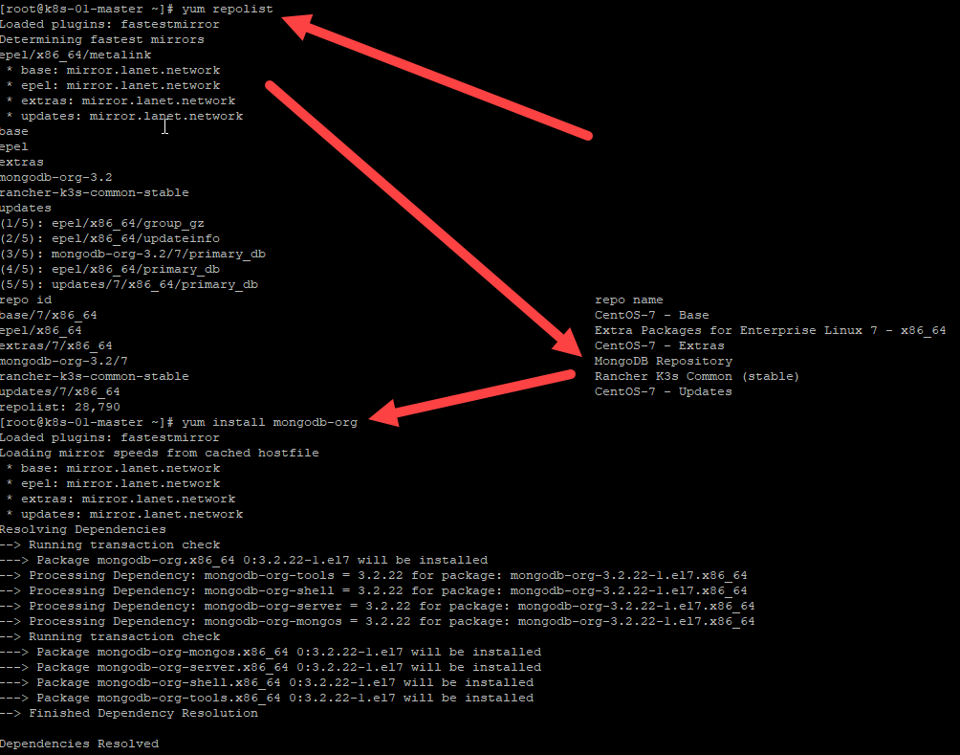

yum install mongodb-org

sudo systemctl start mongod

sudo systemctl status mongod

sudo systemctl restart mongod

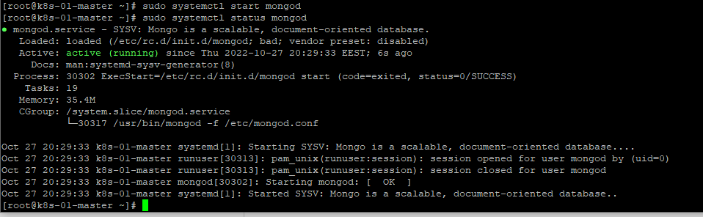

# mongo

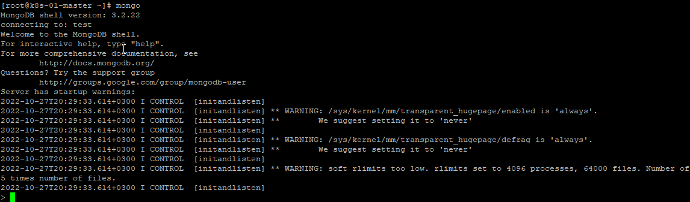

> show dbs;

17. Create a database. Use the use command to connect to a new database (If it doesn't exist, Mongo will create it when you write to it).

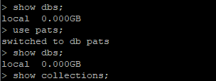

18. Create a collection. Use db.createCollection to create a collection. I'll leave the subject up to you. Run show dbs and show collections to view your database and collections.

> show collections;

19. Create some documents. Insert a couple of documents into your collection. I'll leave the subject matter up to you, perhaps cars or hats.

> db.pats.insertOne({name:'Murzic', age: 5});

{

"acknowledged" : true,

"insertedId" : ObjectId("635ac50a164faef5224fa486")

}

> db.pats.find();

{ "_id" : ObjectId("635ac50a164faef5224fa486"), "name" : "Murzic", "age" : 5 }

> db.pats.insertOne({name:'Barsic', age: 3});

{

"acknowledged" : true,

"insertedId" : ObjectId("635ac5fa164faef5224fa487")

}

20. Use find() to list documents out.

> db.pats.find();

{ "_id" : ObjectId("635ac50a164faef5224fa486"), "name" : "Murzic", "age" : 5 }

{ "_id" : ObjectId("635ac5fa164faef5224fa487"), "name" : "Barsic", "age" : 3 }

>